**Create flows from a Microsoft Power Automate template**

**Choose a template**

Our many templates will get your flows flowing quickly. They'll help you connect the services you're already using in more meaningful ways.

Sign in to [Power Automate](https://ms.flow.microsoft.com/), and select the **Templates** menu. You can sign up for Power Automate with a Microsoft account.

Select the **Save Office 365 email attachments to OneDrive for Business** template.

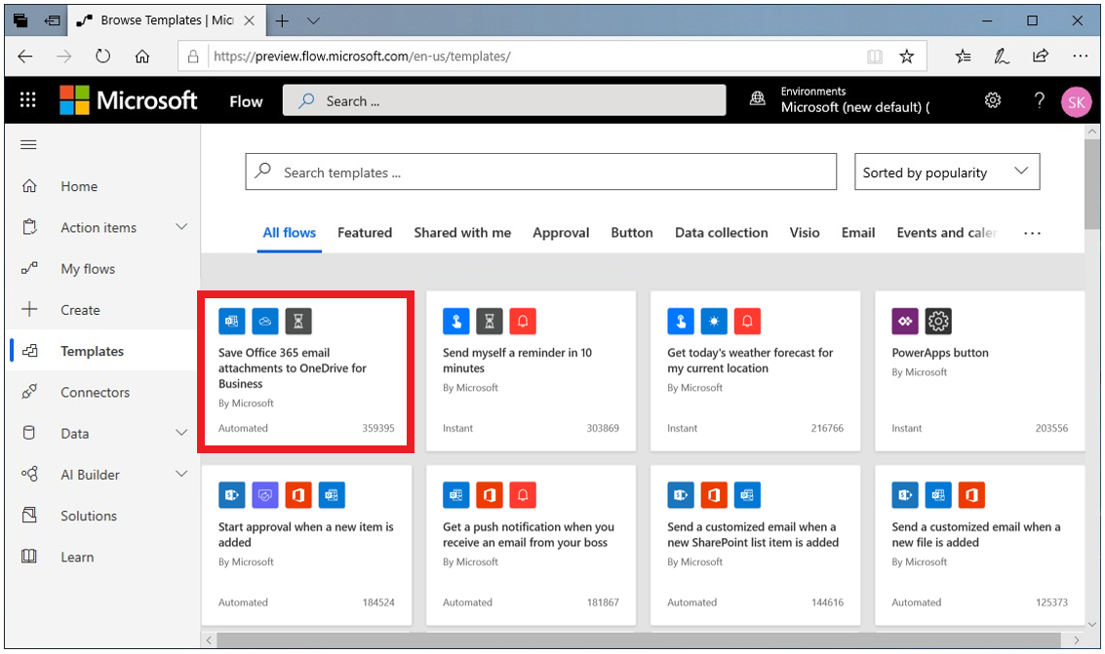

## Create the flow

**Save Office 365 email attachments to OneDrive for Business** is one of our one-click templates, in which you can answer questions that are necessary to build the flow, so that you don't have to write a line of code.

On the template graphic, there's a description of what the template does and what it needs to succeed.

You'll be asked to provide credentials for the Microsoft Office 365 Outlook and Microsoft OneDrive for Business services. If you regularly use both services, you'll already be signed in.

1. Click on the template and select **Create Flow**.
2. On the next page, Power Automate creates the flow for you.
   * It will connect to your work email to get any attachments.
   * It will then create a folder on your OneDrive for Business account to automatically put every attachment that's sent to your work email address in that folder.

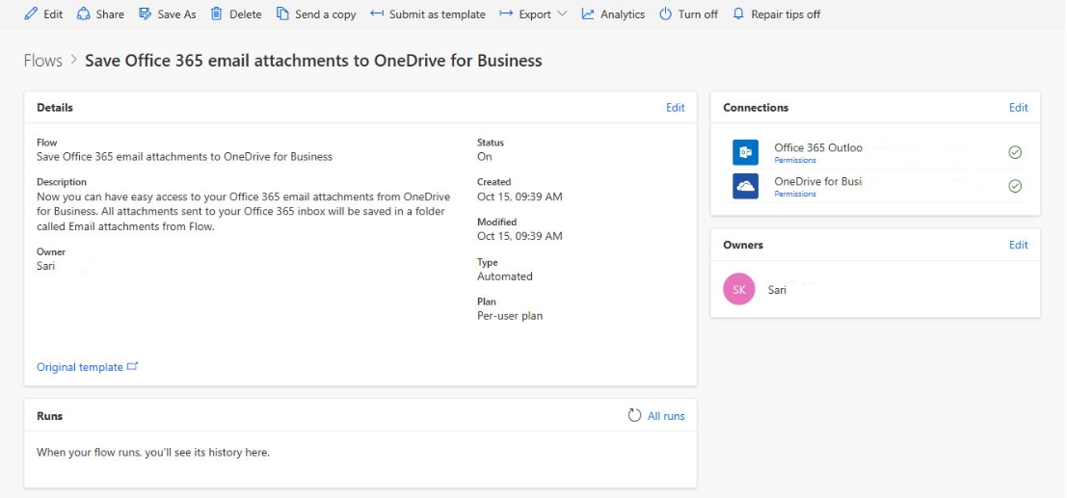

1. Select the **My flows** menu.
2. Select the flow you just created and click **Edit** to see how it works.

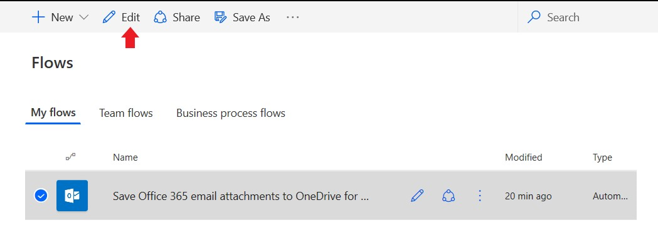

1. Send an email with an attachment, or have another user send an email with an attachment. You then should see a green check mark, which indicates that the flow succeeded.
2. Select **Edit** to see how the flow is defined.
3. Select **Succeeded** to see the run history and the results.

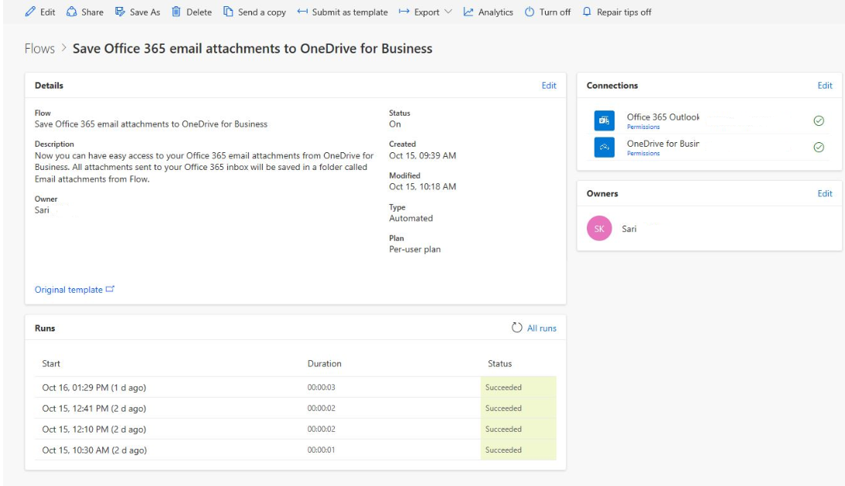

In this case, all parts of the flow were successful.

